Isle of Wight County Sesquicentennial Commemoration
Package for Teachers January 31, 2014

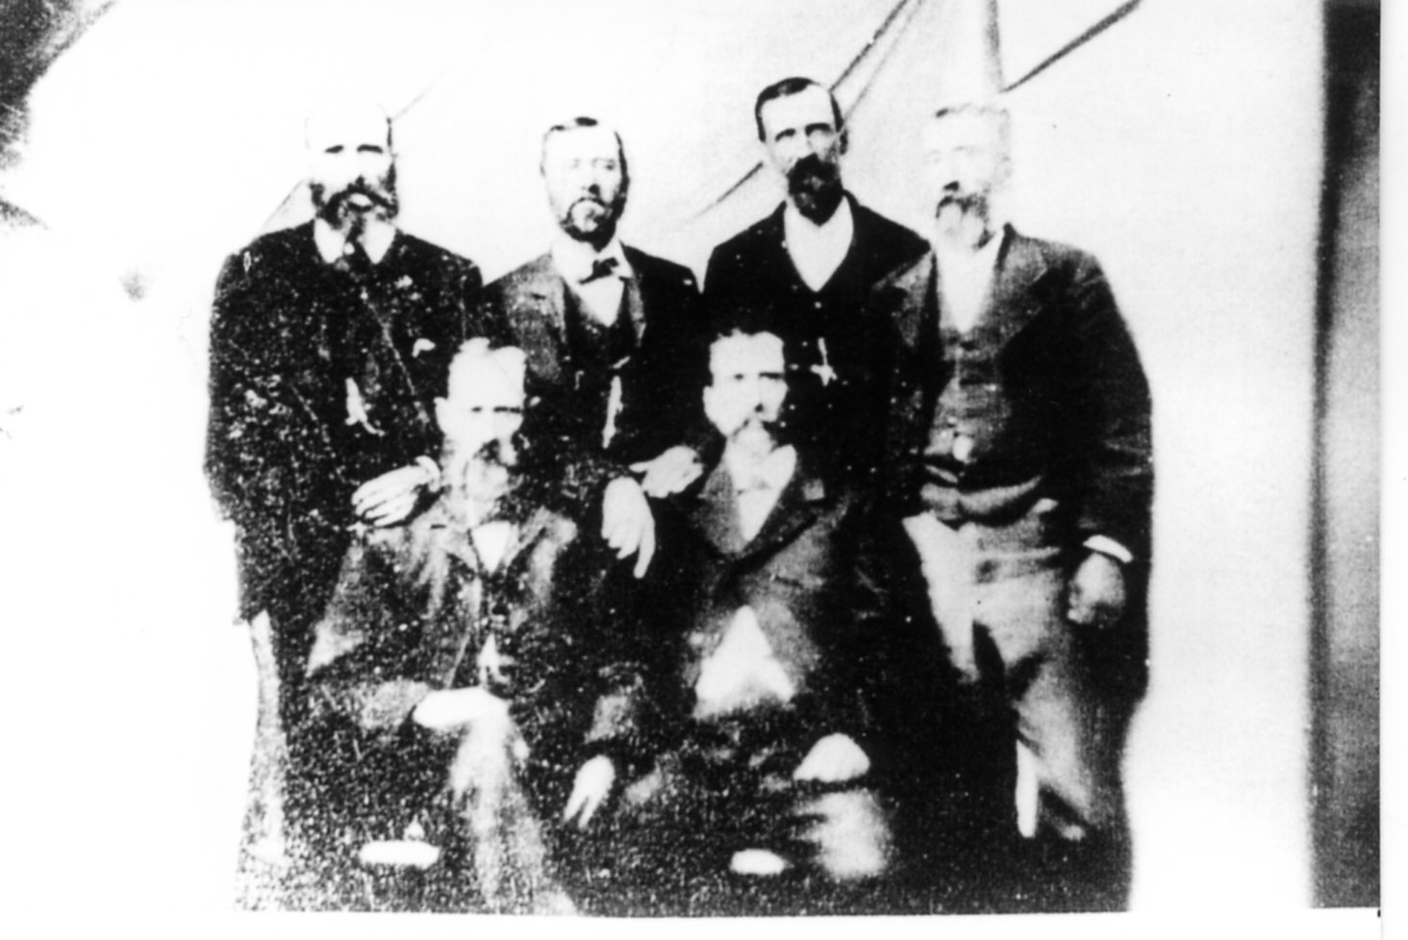

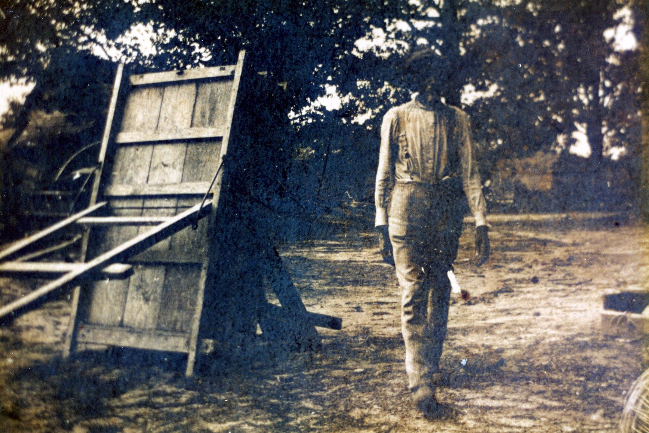

Sponsored by Isle of Wight County Division of Historic Resources & Isle of Wight County Sesquicentennial Committee
Secession
At the opening of the Civil War, Virginia was important for one reason: its strategic location.
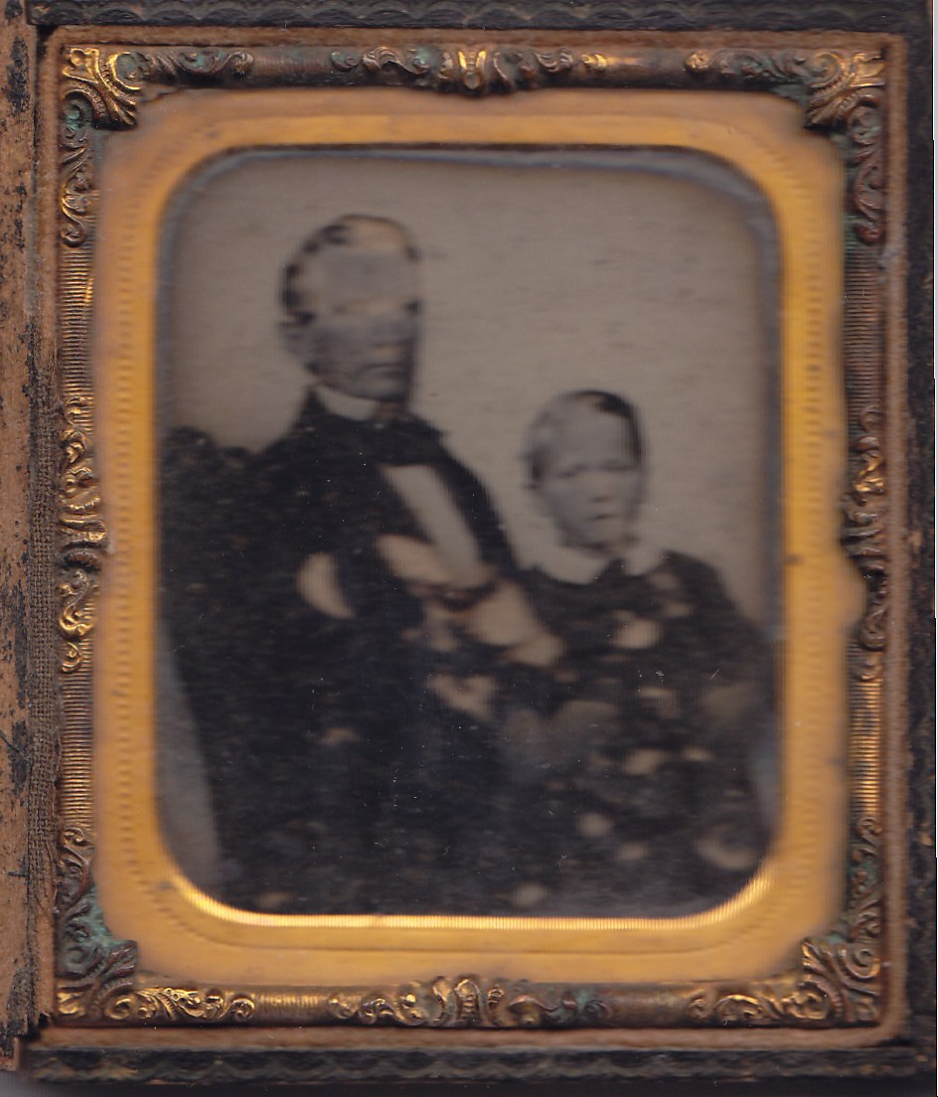
Because of this, Virginians were torn over the decision of whether or not to secede. Virginia was sandwiched geographically, economically, socially and culturally between the North and the South. Although several southern states, following the lead of South Carolina, seceded shortly after Lincoln's election to the presidency and although several more left after Lincoln’s inauguration, Virginia did not break its ties with the Union until the North took military action against the South. While the decision to secede came quickly, it was the product of months of ardent debate. Only after actual war had broken out between the North and the South did Virginia secede from the Union.
Dr. John R. Purdie. One of Isle of Wight County’s prominent citizens, Dr. John R. Purdie, questioned Isle of Wight and Virginia’s possible secession from the Union. In January 1861, he posted 12 questions at the post office for residents to consider.
Dr. John R. Purdie
Photo courtesy of Doris Gwaltney
Some Questions for Plain Men Which Candidates for the Convention are Requested to Answer
1st -- What complaints of the South against the North will secession remove?
2nd – Will secession annul the election of A. Lincoln?
3rd – Will it cause Black Republicans to love and respect us?
4th -- Will it prevent the escape of our slaves?
5th –Will it facilitate their recovery from Northern States?
6th – Will it repeal the Personal Liberty bills which Jonson, a Senator from Georgia, asserts “have not operated to prevent the execution of the Fugitive Slave Laws”?
7th – Will it insure the execution of the Fugitive Slave Laws, which Mr. Rhett & other statesmen of South Carolina have pronounced palpably “unconstitutional”?
8th – Will it secure protection to slaves in the territories?
9th – Will it widen our vicinity with an anti-slave country?
10th – Will it prevent hostile incursions into slave states?
11th – Will it diminish the expenses of government or lessen the taxes on the people?
12th – Will secession promote the interests of our people?

In 1860, the population of Isle of Wight was composed of:
5,037 White
3,570 Enslaved
1,370 Free

Questions
Who could vote for succession in Isle of Wight County?
After reading the questions above, how would you answer number 8?
After reading the questions posed by Dr. John R. Purdie, how do you think Isle of Wight residents voted?
Virginia Ordinance of Secession, April 17, 1861

AN ORDINANCE
To Repeal the ratification of the Constitution of the United States of America, by the State of Virginia, and to resume all the rights and powers granted under said Constitution:
The people of Virginia, in their ratification of the Constitution of the United States of America, adopted by them in Convention, on the 25th day of June, in the year of our Lord one thousand seven hundred and eight-eight, having declared that the powers granted them under the said Constitution were derived from the people of the United States, and might be resumed whensoever the same should be perverted to their injury and oppression, and the Federal Government having perverted said powers, not only to the injury of the people of Virginia, but to the oppression of the Southern slaveholding States.
Now, therefore, we, the people of Virginia, do declare and ordain that the Ordinance adopted by the people of this State in Convention, on the twenty-fifth day of June, in the year of our Lord one thousand seven hundred and seventy-eight, whereby the Constitution of the United States of America was ratified, and all acts of the General Assembly of this State, ratifying or adopting amendments to said Constitution, are hereby repealed and abrogated; that the union between the State of Virginia and the other States under the Constitution aforesaid, is hereby dissolved, and that the State of Virginia is in the full possession and exercise of all the rights of sovereignty which belong to a free and independent State. And they do further declare that the said Constitution of the United State of America is no longer binding on any of the citizens of this State.
This Ordinance shall take effect and be an act of this day when ratified by a majority of the votes of the people of this State, cast at a poll to be taken thereon on the fourth Thursday in May next, in pursuance of a schedule hereafter to be enacted.
Done in Convention, in the city of Richmond, on the seventeenth day of April, in the year of our Lord one thousand eight hundred and sixty-one, and in the eighty-fifth year of the Commonwealth of Virginia
JNO. L. EUBANK,
Sec'y of Convention.

There were 861 registered voters in Isle of Wight County, and they all voted for succession. Historians feel that all the able-bodied men in the county joined the Confederate Army or Navy leaving women, children and older men behind.

Questions
How would you vote and why?
How do you think the voters of Isle of Wight responded?
Local Residents Go to War

The seven Roberts brothers – Sylvester, Stephen, Nathaniel, Mills, John, Francis and Benjamin – were residents of Windsor, and all enlisted in the Confederate Army. Six enlisted on April 22, 1861, and six were wounded in battle. All the brothers returned home after the surrender at Appomattox.

According to descendents, Mary Ann Roberts, told a Union soldier, “I have seven sons in the Confederate Army, and if I had seven more, I would want them to be in the army.”

The image below is a copy of a tintype made as late as 1873. The original tintype is missing one brother: Nathaniel. In the hand-colored version, it appears that the photographer reversed the image, added the missing brother and drew the arm that John lost in battle. Compare the two photographs. Try to find the missing brother and the missing arm.

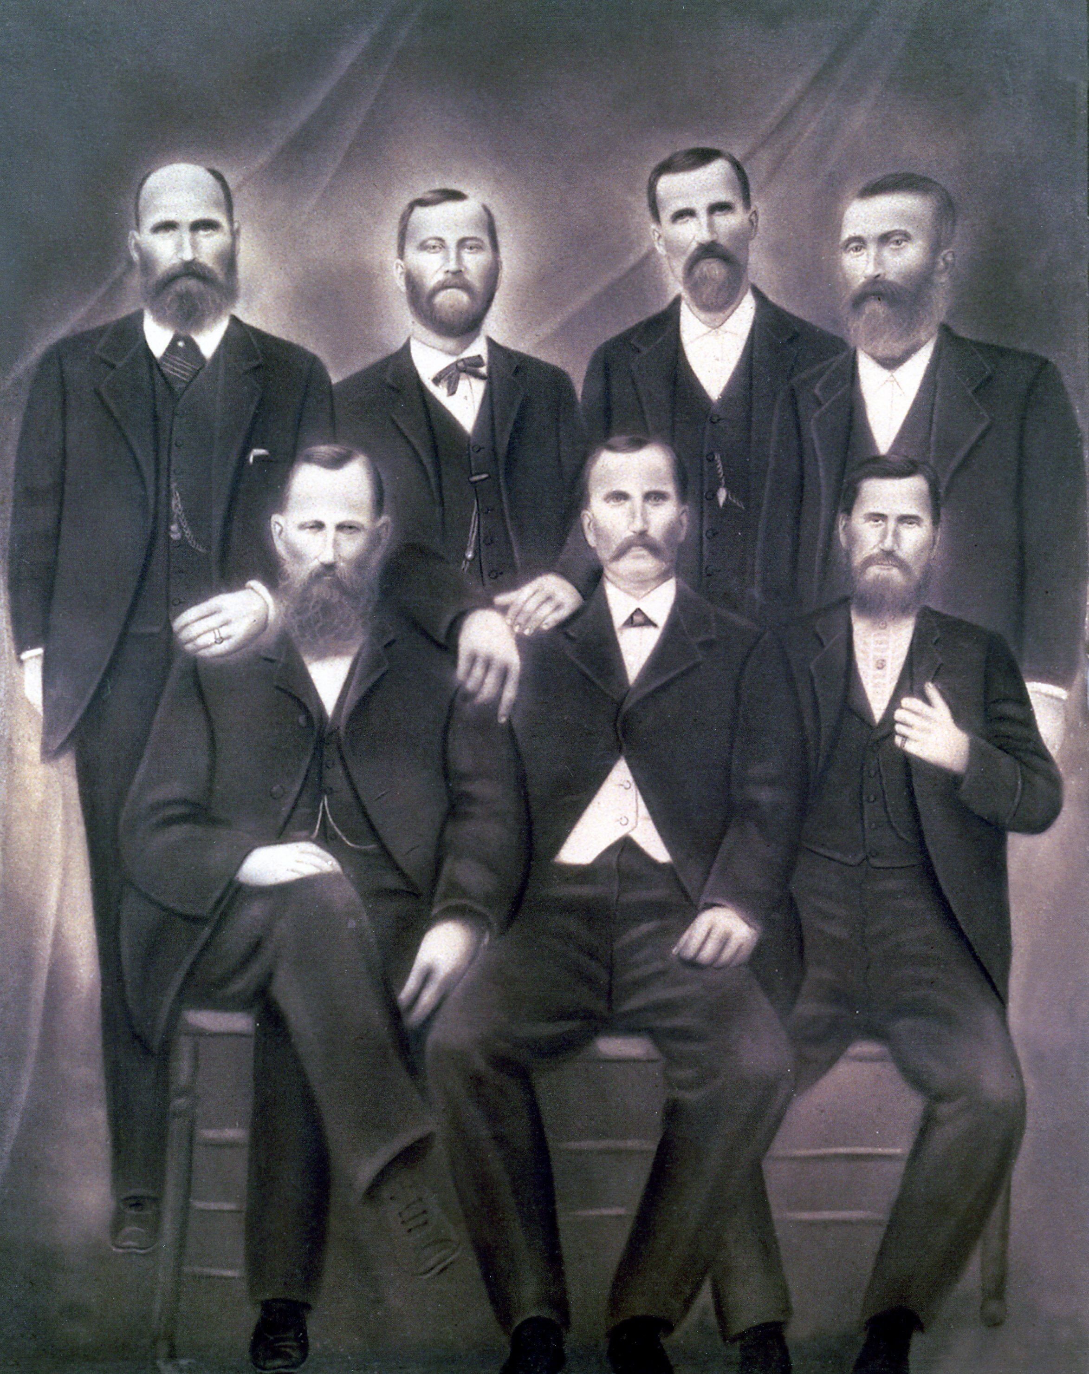

Museum Collection IW79-99
Museum Collection IW134-99

Photography became popular during the Civil War. Many soldiers had pictures taken while they were in uniform and carried pictures of their loved ones into battle. Below is an image of Sgt. Mills W. Roberts, 16th Virginia Infantry.
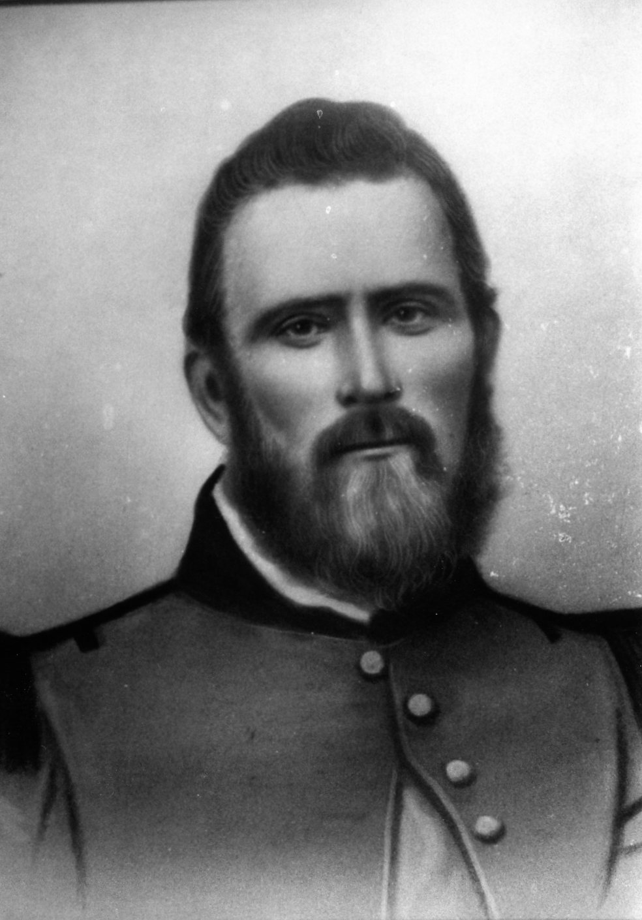

Museum Collection IW233-99

Development of Forts on the James River
The James River stretches northwest for 100 miles from Hampton Roads and Union-held Fort Monroe to the Confederate capital of Richmond. Even before Richmond became the capital, there was a concern that the Union’s more powerful navy would move upriver and take control of the heart of Virginia.
Gen. Robert E. Lee developed a series of defensive forts along the river in April 1861. These forts were to defend the river and stop the enemy from advancing. Six fortifications were developed. They were named Fort Boykin, Fort Huger, Mulberry Island Point Battery, Jamestown Island Battery, Fort Powhatan and Drewry’s Bluff Battery. Fort Boykin and Fort Powhatan were already in developed locations, but the other fortifications were constructed. Eventually all but Drewry’s Bluff Battery fell during the Union advancement.
Questions
Which fort was the Confederate first line of defense?
Looking at the map, why were the placement of Mulberry Island Point Battery and Fort Huger strategically important?
How can the bends in the James River help the in the defense of Richmond?

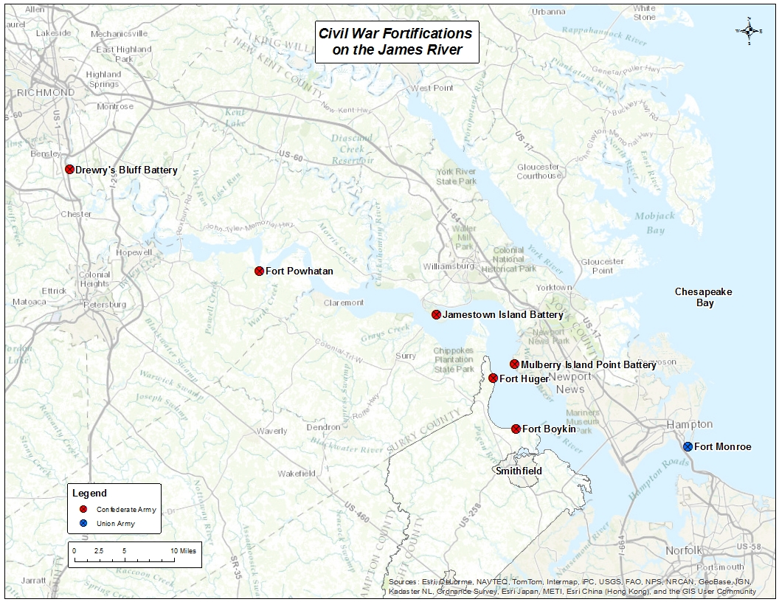
Civil War Engagements in Isle of Wight

Fort Boykin
In 1623, Capt. Roger Smyth constructed a fort to protect English settlements from Native Americans and Spaniards. Because of the elevation and view of the James River, this area was named The Castle. During the Revolutionary War, the fort was expanded and named Fort Boykin in honor of Maj. Francis Boykin. It was refortified during the War of 1812. Between June 1861 and May 1862, the Confederate Army rebuilt and enlarged the fort as a part of their defensive system. It was one of in a series of earthworks designed to prevent inland invasion by the Union, whose buildup at the mouth of the James River posed a severe threat to Richmond, the Confederate capital. On May 8, 1862, a flotilla of Union ships headed up the James River – including the ironclad USS Galena. Fort Boykin quickly found that its guns had too short of a range. After a few hours of bombardment, the Confederates spiked the cannons, blew-up the shot furnace and abandoned the fort.

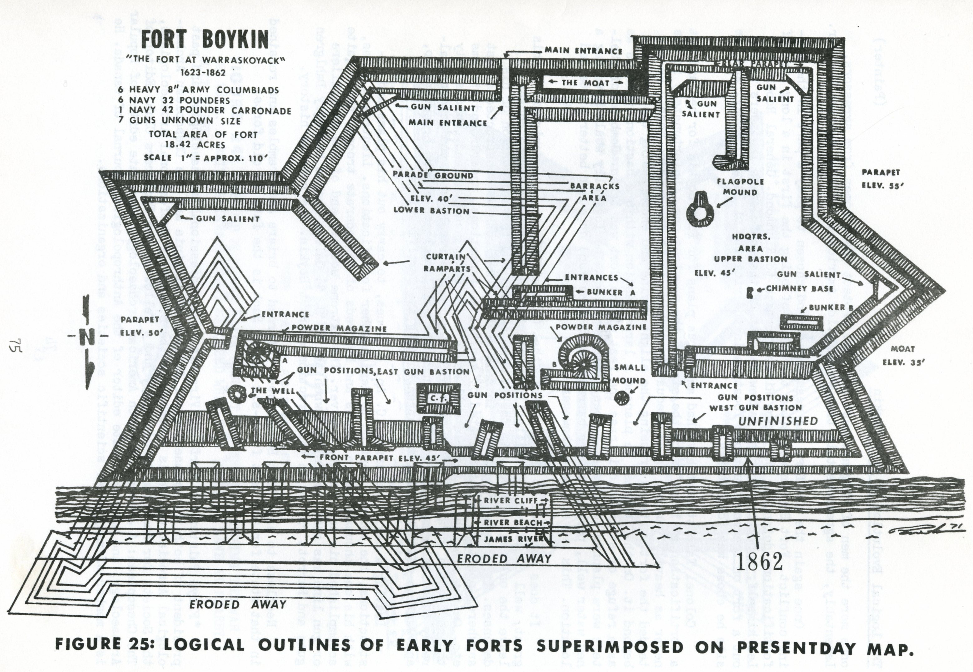

Fort Huger
As part of the Confederate defense of the James River, Fort Huger was constructed on a bluff upriver from Fort Boykin and across from the Mulberry Island fortification. The fort was named for Confederate Gen. Benjamin Huger, commander of the Department of Norfolk. Local slaves and free blacks helped dig the fortification, and it was armed with heavy artillery. After the USS Galena fired on Fort Boykin, the flotilla continued upriver to Fort Huger. After two hours of bombardment and another attack on May 14, the Confederates spiked the cannons and abandoned the fort. The name is pronounced Hu-gee.

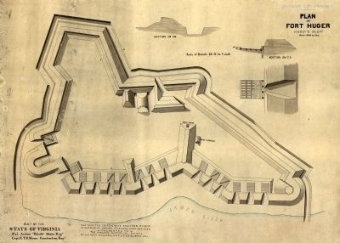

Battle of Smithfield
On Jan. 31, 1864, a unit of Union soldiers sailed up the Pagan River to investigate Confederate activity. After landing and heading inland, they encountered a small Confederate unit, and after a minor skirmish, the Union detachment headed back to Smithfield to leave the area. Their gunboat departed without them forcing the soldiers to spend the night. Confederate Maj. N.A. Sturdivant took the opportunity to capture the Union troops. On Feb. 1, a skirmish along Main Street ensued. During the three-hour engagement, the Union gunboat Smith-Briggs arrived, and the Union troops attempted to escape. Capt. Joseph Norsworthy cut off the Union retreat with cavalry. The gunboat was destroyed by Confederate cannon fire, and the Union forces were captured.

Union Gunboat Smith-Briggs
Museum Collection 779-85
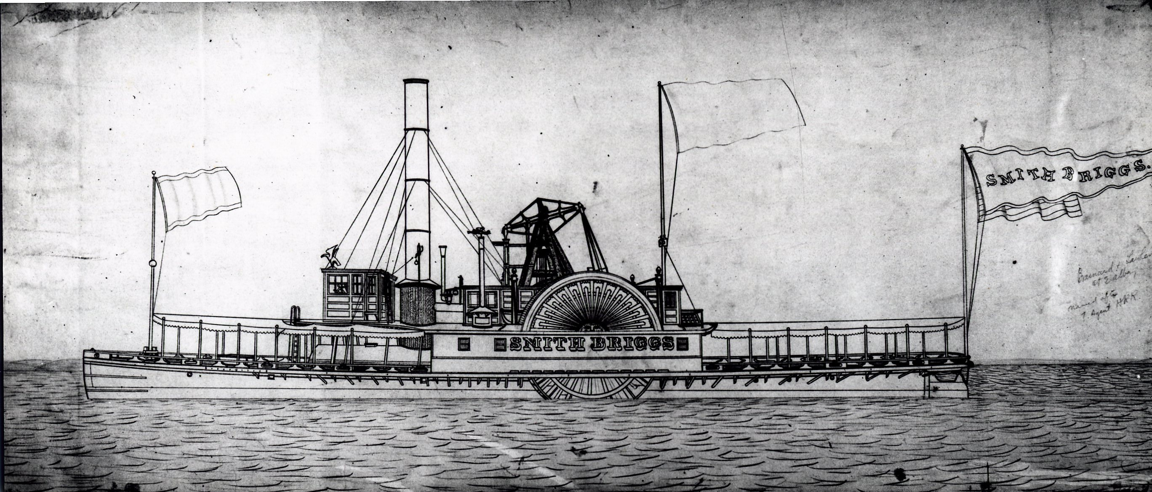
Capt. Joseph Norsworthy Museum Collection 4000.257-93
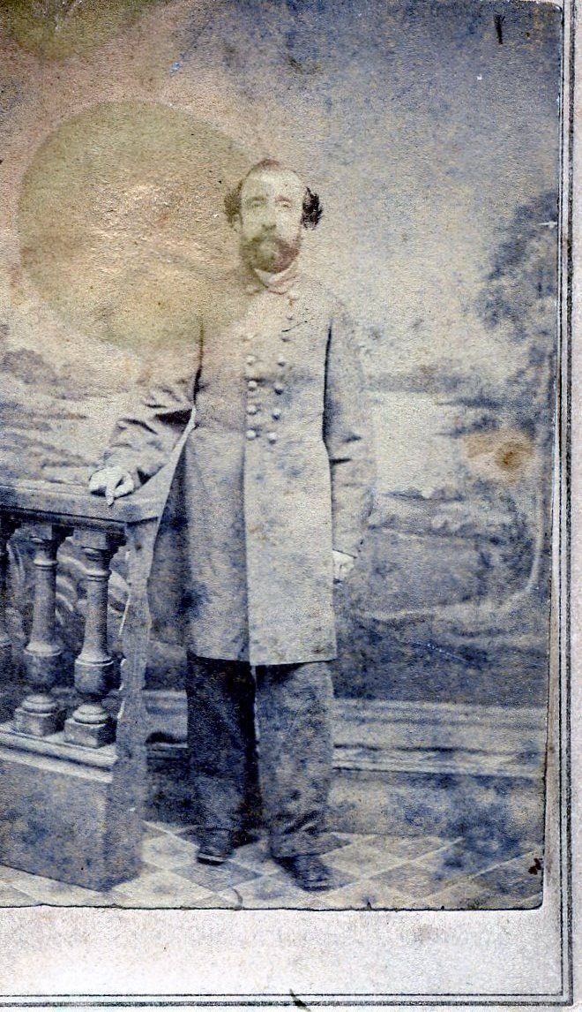
The Railroad: An Important Link

The railroad was one of the best ways to move troops and supplies inland during the Civil War. Suffolk had two railroads running through town. The Portsmouth-Roanoke and the Norfolk-Petersburg routes both opened a way to Richmond for the Union Army. Suffolk was taken in May of 1862, and the Union Army attempted to move towards Richmond through Isle of Wight County.

Suffolk to Zuni. The small hamlet of Zuni was near the railroad bridge that traversed the Blackwater River. Confederate troops were stationed there from 1862 to 1864. During this period, both Confederate and Union troops pulled up and laid rail lines. They also fought skirmishes through the areas of Windsor, Carrsville and Franklin.

Foraging Expedition in Isle of Wight. In April 1863, Lt. Gen. James Longstreet was sent by Gen. Robert E. Lee to Southeastern Virginia to forage for supplies and attempt to remove the Union stronghold in Suffolk. After a few failed attempts to take the city of Suffolk, Longstreet’s troops focused on gathering food for the Army of Northern Virginia. During their stay in the southern end of Isle of Wight, the Confederate soldiers gathered so much food that they had to seize horses, oxen, wagons and carts from the local residents. The Confederate army paid the farmers for the food – although they paid with Confederate currency.

In a receipt belonging to local farmer John Riddick, he lists his sales. The going rate for corn was $1.50 per pound and $2 per 100 pounds of fodder, food for animals.
April 17th 500 pounds fodder $10.00
April 18th 15 bushels corn $28.50
640 pounds fodder $14.40
April 19th 360 pounds fodder $8.10

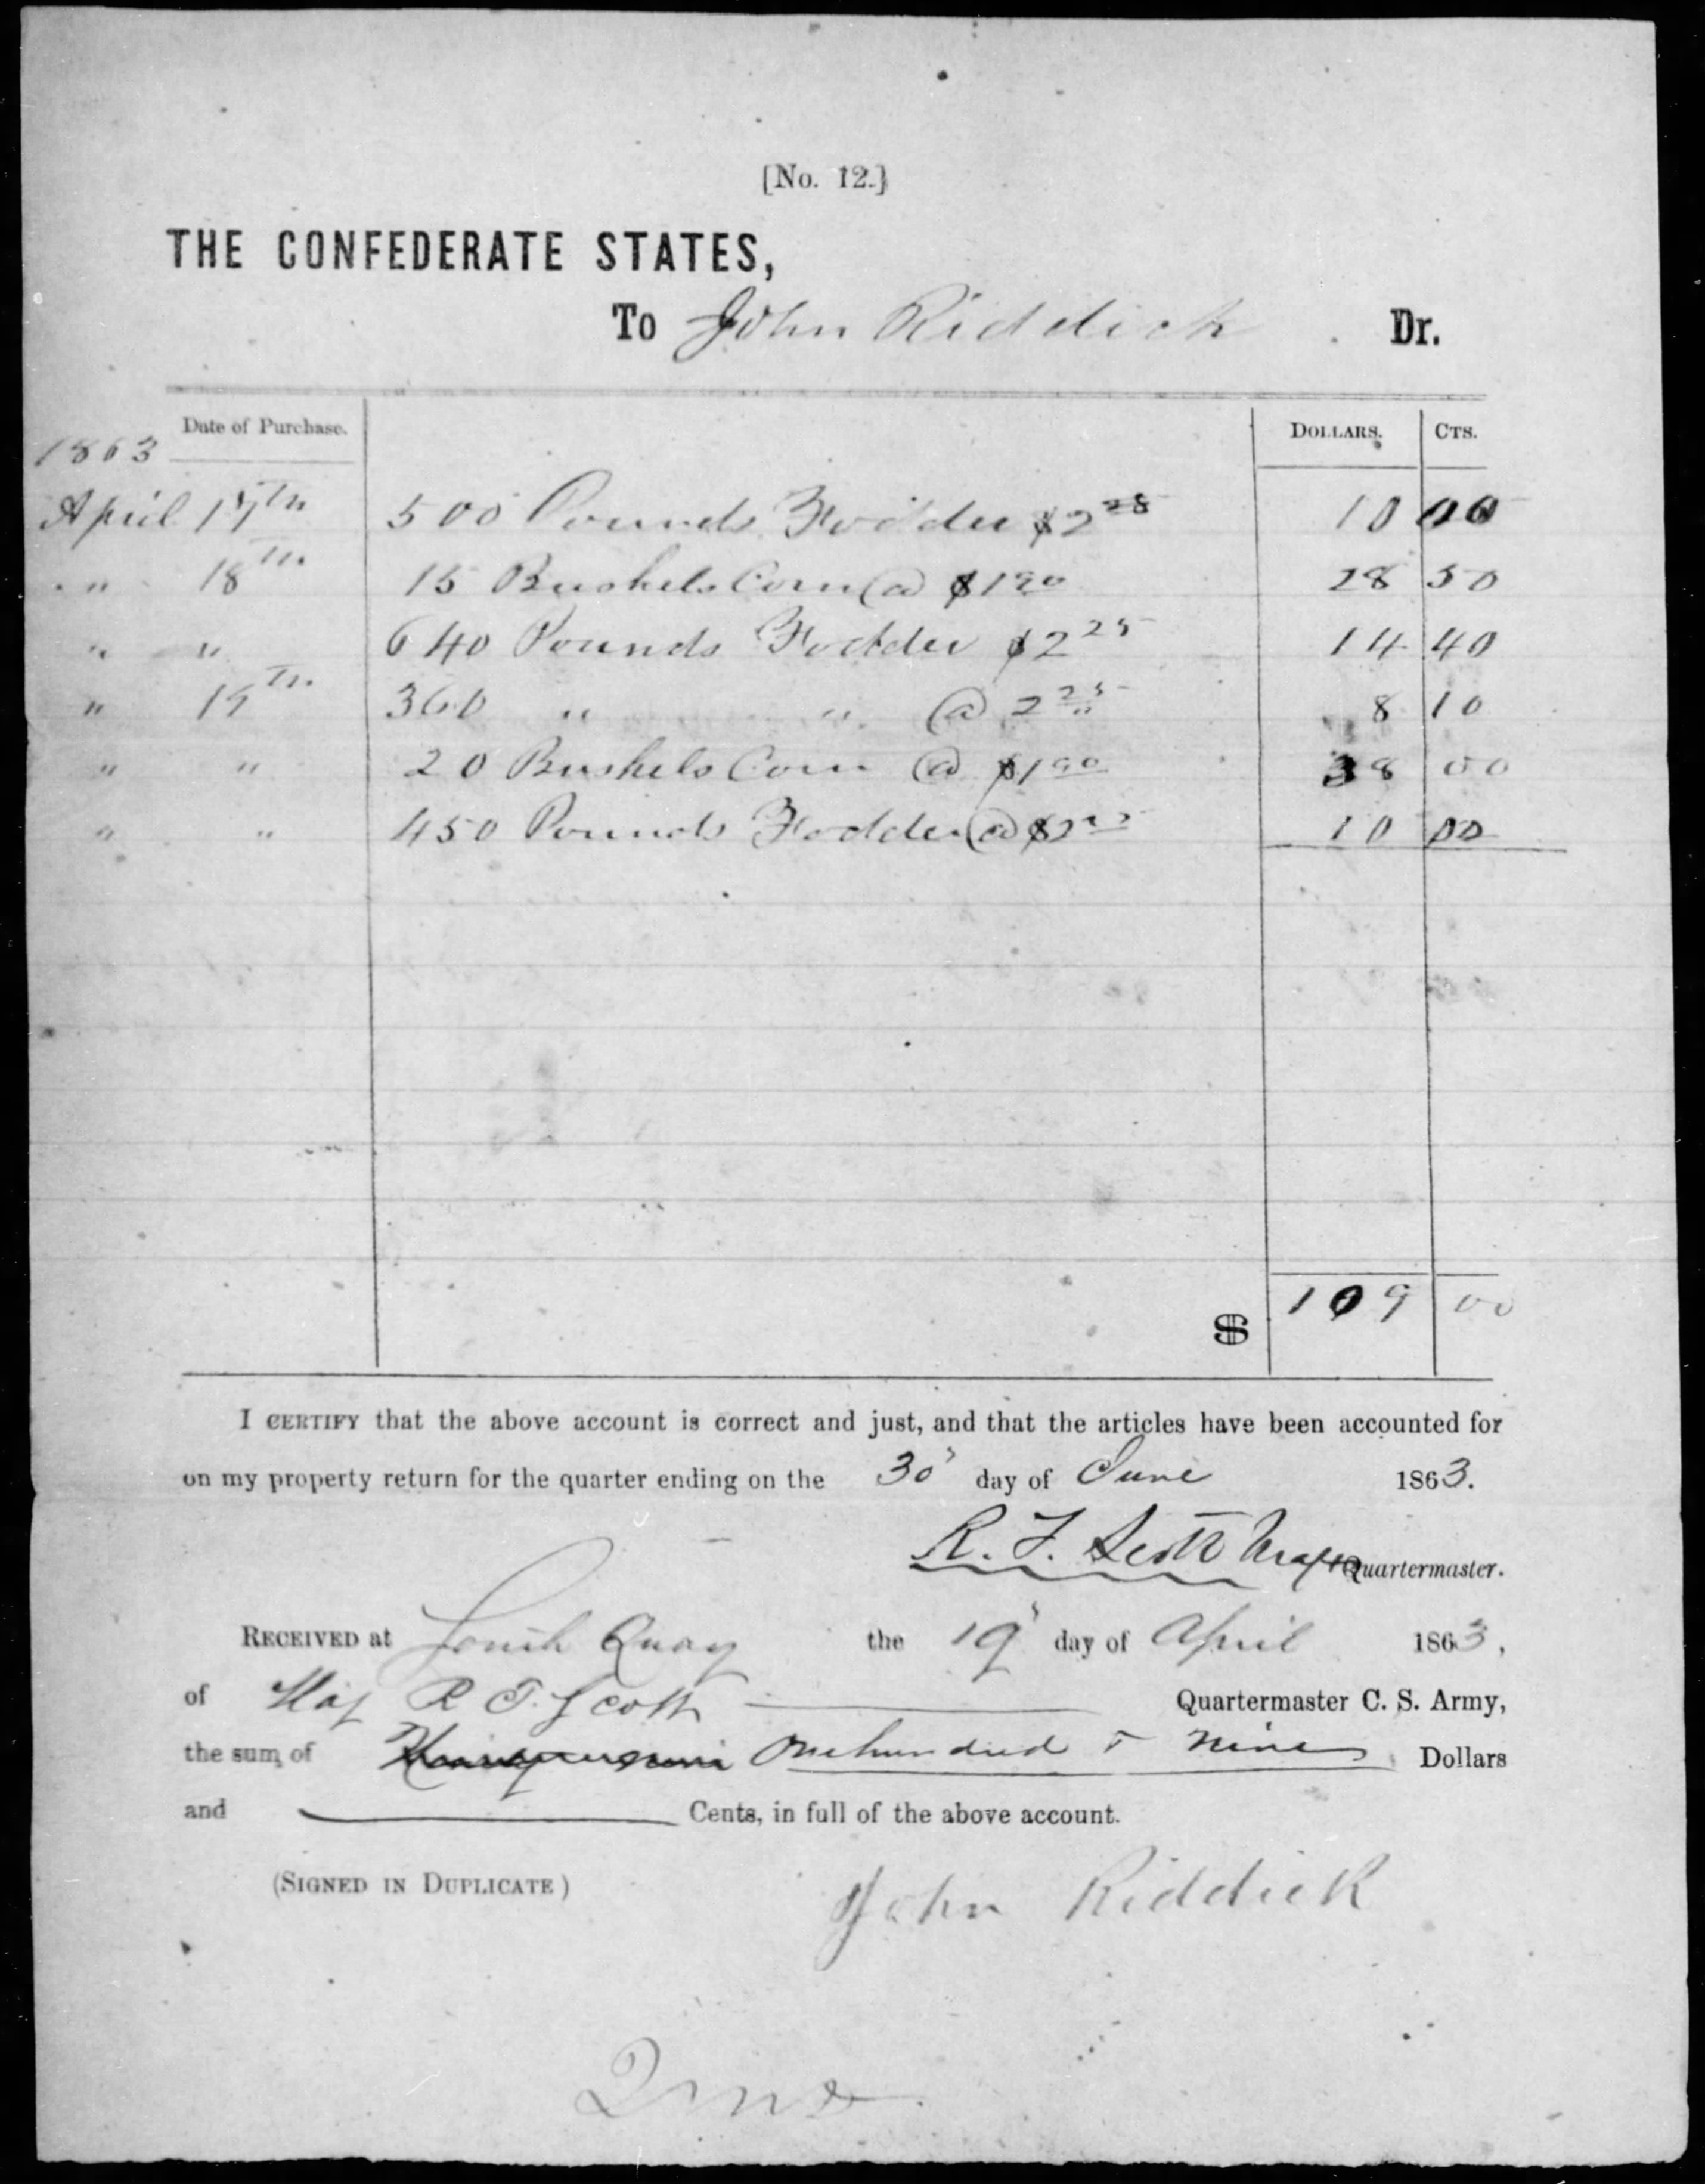 Courtesy National Archives
Historians feel that Longstreet’s foraging expedition in Isle of Wight County, Nansemond County and Gates County, N.C., secured enough meat to feed his army of 20,000 men for a month. This gave rise to the army’s sustainability in the July 1 to 3, 1863, Battle of Gettysburg in Pennsylvania.
African-American Population

The African-American population in Isle of Wight County during the Civil War consisted of both free and enslaved people. The free population was well established, and many families lived on farms throughout the county.

Free African-Americans and Fort Huger. The Confederate Army constructed a fort near Harden’s Bluff, across the James River from Mulberry Point, to fire upon Union vessels. Construction of the fort was difficult due to lack of manpower for the clearing of trees, digging of trenches and placement of the weapons. The Confederate Army rented slave labor and hired free black laborers. Records of their payment show that these men worked for 50 cents a day.

There are two payrolls produced by Acting Paymaster James Maurice: one for slaves and one for “sundry persons,” free men hired by the Confederate Engineering Department to work on Fort Huger.

Questions
Looking at both lists, what are some of the similarities between the two working conditions?
Who receive the payment for the day’s work?
In looking at the lists, can you tell if any of the workers are related?
On average, how many days a month did the slaves work?
On average, how many days a month did the free men work?
Why do you think some of the free men bought tobacco and shoes from the Confederacy?
On the slave list, what other services are noted?
What do the other services tell us about the status of slaves in Isle of Wight?
Looking at the Notice. Pay Office Engineer Department of VA, when was the pay officer going to arrive at T.B. Bourne’s residence near Day’s Point, Smithfield and Zuni on N(orfolk) and P(ortsmouth) R.R.?
Do you think the free men were treated fairly?
Read the letter from B.J. Gray to James Maurice. What tone does the letter have?

Pay Roll of Slaves ^{from Isle of Wight County} employed by the Commonwealth of Virginia, for Coast, Harbor and defences, on the defensive works

At Hardy’s Bluff in the month of August 1861
We, the undersigned, acknowledge to have received of 1st Sect. James Maurice, Acting Paymaster, Eng. Dept. the amounts set opposite our names respectively, in full payment for the services of our Slaves for the specified, having signed duplicate receipts.

From Whom Hired | Names | Occupation | Time Employed  Days | Rate of Pay  Per day | Amount for each slave | Net Amount for each slave
Edwin White | Levy | Carpenter | 23 ½ | 1.00 | 23.50 | 23.50
 | Willis | “ | 25 | “ | 25.00 | 25.00
 | Roderick | “ | 25 | “ | 25.00 | 25.00
 |  |  | 73 ½ |  | 73.50 | 73.50
William Hall | James | Labourer | 17 ½ | .50 | 8.75 | 8.75
 | Charles | “ | 17 ½ | “ | 8.75 | 8.75
John E. Thomas | Solomon | “ | 10 ½ | “ | 5.25 | 5.25
 | James | “ | 10 ½ | “ | 5.25 | 5.25
 | Henry | “ | 10 ½ | “ | 5.25 | 5.25
 | Burwell | “ | 10 ½ | “ | 5.25 | 5.25
 | Reuben | “ | 10 ½ | “ | 5.25 | 5.25
 | Ben | “ | 10 ½ | “ | 5.25 | 5.25
 | Mike | “ | 10 ½ | “ | 5.25 | 5.25
 | Leonard | “ | 10 ½ | “ | 5.25 | 5.25
 | Edmund | “ | 10 ½ | “ | 5.25 | 5.25
 | Abraham | “ | 10 ½ | “ | 5.25 | 5.25
E. A. Madera | Isaac | “ | 19 ½ | “ | 9.75 | 9.75
 | John | “ | 18 ½ | “ | 9.25 | 9.25
 | Alfred | “ | 17 | “ | 8.50 | 8.50
 | Moses | “ | 20 ½ | “ | 10.25 | 10.25
 | Henry | “ | 21 | “ | 10.50 | 10.50
 | Edmund | “ | 17 | “ | 8.50 | 8.50
E.P. Crenshaw | Robert | “ | 15 ½ | “ | 7.75 | 7.75
 | 2 horse wagon | Hauling | 21 ½ | 2.00 | 43.00 | 43.00
James Branch | 1 mule cart & driver | Hauling | 4 | 1.50 | 6.00 | 6.00
 |  |  | 294 ½ |  | 183.50 | 183.50
 | Carpentry | $73.50
 | Labor | 183.50
 |  | 257.00

Pay Roll of sundry persons free negroes from Isle of Wight Co. employed by the Commonwealth of Virginia, for Coast, Harbor and defences, on the defensive works

At Fort Huger in the month of September 1861
We, the undersigned, acknowledge to have received of 1st Sect. James Maurice, Acting Paymaster, Eng. Dept. the amounts set opposite our names respectively, in full payment for the services of our services for the specified, having signed duplicate receipts.

Names | Occupation | Time Employed  Days | Rate of Pay  Per Day | Amount | Deductions  On What Account | Deductions  Amount | Net Amount
Thomas Aldiman | Labourer | 21 | .50 | 10.50 | 2 lbs. Tobacco | 1.00 | 9.50
Henry Briggs | “ | 22 ½ | “ | 11.25 |  |  | 11.25
Peyton Bailey | “ | 14 ½ | “ | 7.25 |  |  | 7.25
W.J.W. Bailey | “ | 20 | “ | 10.00 | 1 pr. Shoes | 2.25 | 7.75
George Bailey | “ | 23 | “ | 11.50 |  |  | 11.50
William Butler | “ | 12 ½ | “ | 6.25 |  |  | 6.25
Mills Butler | “ | 6 ½ | “ | 3.25 |  |  | 3.25
Ansom Bowman | “ | 23 ½ | “ | 11.75 | 1 lb. Tobacco | .50 | 11.25
John Bowser | “ | 23 ½ | “ | 11.75 |  |  | 11.75
Henry Barber | “ | 23 | “ | 11.50 |  |  | 11.50
Allen Crocker | “ | 2 | “ | 1.00 |  |  | 1.00
Silas Charity | “ | 24 ½ | “ | 12.25 | 1 lb. Tobacco | .50 | 11.75
Beverly Clayton | “ | 21 ½ | “ | 10.75 | 1 pr. Shoes | 2.25 | 8.50
Ben Drew | “ | 16 ½ | “ | 8.25 | 1 lb. Tobacco | .50 | 7.75
Joseph Davis | “ | 24 ½ | “ | 12.25 | 1 lb. Tobacco | .50 | 11.75
Henry Gwaltney | “ | 14 ½ | “ | 7.25 |  |  | 7.25
Isaac Green | “ | 5 ½ | “ | 2.75 |  |  | 2.75
Gilbert Green | “ | 5 ½ | “ | 2.75 |  |  | 2.75
Peter Gwaltney | “ | 19 ½ | “ | 9.75 |  |  | 9.75
Robb Hill, Jr. | “ | 12 | “ | 6.00 | 1 lb. Tobacco +1.87 | 2.37 | 3.63
Edica Holloway | “ | 23 | “ | 11.50 | 1 pr. Shoes | 2.25 | 9.25
Robb Hill | “ | 11 ½ | “ | 5.75 | 1 lb. Tobacco | .50 | 5.25
James Holloway | “ | 23 | “ | 11.50 |  |  | 11.50
Robb Holloway | “ | 23 | “ | 11.50 | 1 lb. Tobacco | .50 | 11.00
 |  | 416 ½ |  | 208.25 |  | 13.12 | 195.13

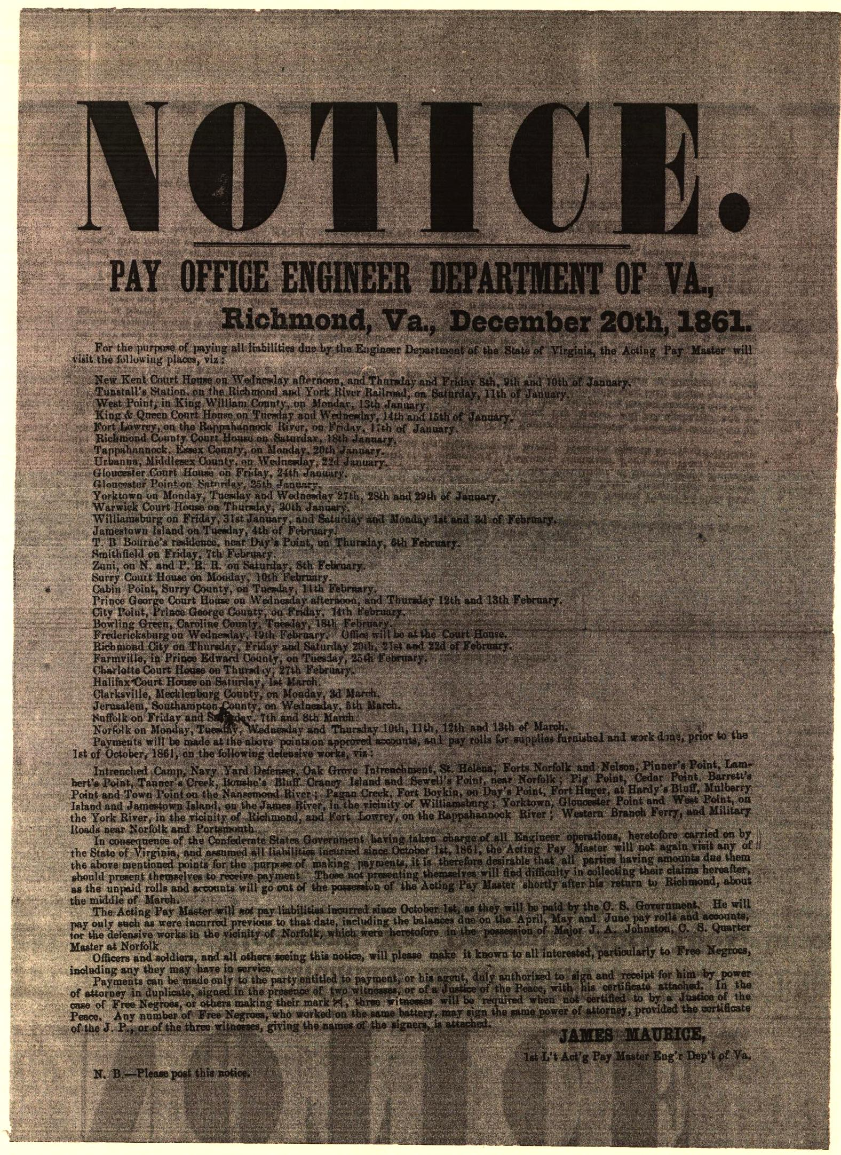
Isle of Wight County, Dec. 10th- 1861

Mr. James Maurice
Dear Sir,
There are a considerable number of free negroes in this and the adjoining county that have not received their pay for work on Batteries. I have seen your advertisement stating in substance- that you would not visit this county again for the purpose of paying off and application must be made to you in Richmond.
Several free negroes have applied to me to get their pay, and I have concluded if you will not be in the county again this year for the purpose of paying off, I will go to Richmond for the money, as they all want a little change for Christmas. I shall make it generally known, and let all have the benefit of it that choose.
I suppose there is some particular formality, and I will thank you to give me the necessary information, so that I may be properly authorized to receive the money.
I would also like to be informed, whether you can be found in Richmond at any time or only at particular times. I can be there on the 20 or 24th, I prefer the 20th.
Please let me hear from you immediately to oblige.

Yours Respy,

B. J. Gray

P.S. I am the Com (Commissioner) of the Revenue for this county and know the free negroes generally.
Randall Booth Saves the Courthouse Records

On May 5, 1862, Clerk of the Circuit Court Nathaniel P. Young received authorization to remove the records from the courthouse to safeguard them. His slave Randall Booth hid the county records in Greenville and Brunswick counties. After the war, Booth returned the records to their rightful home. He was given his freedom and a position as caretaker of the courthouse. Young gave Booth a piece of land for a home, and Booth lived there until his death in 1904.
Randall Booth, Museum Collection 4208.1-95

Fort Monroe and the 36th Infantry, U.S. Colored Troops

In May 1861, Maj. Gen. Benjamin Butler decreed that any male slave arriving at Fort Monroe would be considered contraband of war and not returned to his owner. As the war continued, hundreds of men, women and children escaped to Fort Monroe. In 1863, a unit of Colored Troops was assembled from the many contrabands living at the fort. The 36th Infantry United States Colored Troops was made up of mostly former slaves. When the men enlisted, they were asked their place of birth and occupation. The Union officers did not want to list their occupation as slave, so they listed the soldiers as farmers. Below are the men who enlisted from Isle of Wight:

Company E
- Adkins, Richard, Private; 32; Isle of Wight County, Va..; Farmer; October 19, 1863-November 20, 1863; Died at Portsmouth, Va., on November 20, 1863.
- Edwards, Solomon, Private; 46; Isle of Wight County, Va..; Farmer; December 25, 1863-March 4, 1865; Wounded in action at New Market Heights, Va., September 29, 1864; Discharged before Richmond, Va., March 4, 1865.
- Reddick, Charles, Private; 18; Isle of Wight County, VA.; Farmer; August 13, 1863-August 13, 1866; Mustered out on expiration of enlistment, August 13, 1866; Post-war service Co. C, 39th U.S. Infantry and Cos. A, I, 25th U.S. Infantry; Died October 13, 1923, at Bedford, Va.
- Thomas, William H., Private; 20; Isle of Wight County, Va.; Farmer; August 13, 1863-August 13, 1866; mustered out on expiration of enlistment, April 13, 1866.

Company F
- Dealt, Walter, Private; 22; Isle of Wight County, Va.; Farmer; September 1, 1863-September 1, 1866; Mustered out on expiration of enlistment, August 24, 1866.

Company I
- Cook, Joseph, Private; 22; Isle of Wight County, Va.; Boatman; September 15, 1863-September 20, 1866; Mustered out at expiration of enlistment, September 20, 1866.
- Ely, Lewis, Private; 36; Isle of Wight County, Va.; Lumberman; September 15, 1863-; absent sick at Fort Monroe, Va. (since May 31, 1864); mustered out of regiment.
- Outland, Moses, Private; 18; Isle of Wight County, VA.; Farmer; September 16, 1863-September 20, 1866; mustered out at expiration of enlistment, September 20, 1866.

Company K
- Green, Solon, Private; 24; Smithfield, VA.; Miner; April 9, 1865-October 28, 1866; mustered out with the regiment; died October 7, 1909.
- Grey, Dawson (Dawson Gray), Private; 19; Isle of Wight County, VA.; Farmer; October 1, 1863-October 1, 1866; mustered out at expiration of enlistment, October 1, 1866; died April 1, 1922, at Chuckatuck, Va.
- Jordan, Miles H., Private; 18; Isle of Wight County, VA.; Farmer; September 30, 1863-September 30, 1866; Mustered out at expiration of enlistment, September 30, 1866; Post-war service in Co. D, 40th U.S. Infantry and Co. C, 25th U.S. Infantry.

Questions
Why was there a separate regiment for African-Americans?
What was the average age of a soldier from Isle of Wight?
What do you think a boatman does for a living?
How do you think slaves arrived at Fort Monroe?
How many survived the war?
After the war, did any continue with their military service?

Suggested Reading
The 36th Infantry United States Colored Troops in the Civil War: A History and Roster. By James K. Bryant, II, 2012.
The War Hits Home: The Civil War in Southeastern Virginia. By Brian Steel Wills, 2001.
River of Lost Opportunities: The Civil War on the James River, 1861-1862. By Ed Bearss, 1995.
Historical Notes on Isle of Wight County, Virginia. Helen Haverty King, 1993.

Other References
The state commission sent copies of its Emmy-nominated piece Virginia in the Civil War: A Sesquicentennial Remembrance to every school in the state in 2009.
http://www.virginiacivilwar.org/education.php

Virginia Standards of Learning Ties

Civil War and Postwar Eras
VS.7 The student will demonstrate knowledge of the issues that divided our nation and led to the Civil War by
a) identifying the events and differences between northern and southern states that divided Virginians and led to secession, war and the creation of West Virginia;
b) describing Virginia’s role in the war, including identifying major battles that took place in Virginia;
c) describing the roles played by whites, enslaved African Americans, free African Americans and American Indians.
VS.8 The student will demonstrate knowledge of the reconstruction of Virginia following the Civil War by
a) identifying the effects of Reconstruction on life in Virginia;
b) identifying the effects of segregation and “Jim Crow” on life in Virginia for whites, African Americans and American Indians;
c) describing the importance of railroads, new industries and the growth of cities to Virginia’s economic development.

Civil War: 1861 to 1865
USI.9 The student will demonstrate knowledge of the causes, major events and effects of the Civil War by
a) describing the cultural, economic and constitutional issues that divided the nation;
b) explaining how the issues of states’ rights and slavery increased sectional tensions;
c) identifying on a map the states that seceded from the Union and those that remained in the Union;
d) describing the roles of Abraham Lincoln, Jefferson Davis, Ulysses S. Grant, Robert E. Lee, Thomas “Stonewall” Jackson and Frederick Douglass in events leading to and during the war;
e) using maps to explain critical developments in the war, including major battles;
f) describing the effects of war from the perspectives of Union and Confederate soldiers (including African American soldiers), women and enslaved African Americans.

Civil War and Reconstruction: 1860 to 1877
VUS.7 The student will demonstrate knowledge of the Civil War and Reconstruction Era and their importance as major turning points in American history by
a) evaluating the multiple causes of the Civil War, including the role of the institution of slavery as a principal cause of the conflict;
b) identifying the major events and the roles of key leaders of the Civil War Er, with emphasis on Abraham Lincoln, Jefferson Davis, Ulysses S. Grant, Robert E. Lee and Frederick Douglass;
c) analyzing the significance of the Emancipation Proclamation and the principles outlined in Lincoln’s Gettysburg Address;
d) examining the political and economic impact of the war and Reconstruction including the adoption of the 13th, 14th and 15th Amendments to the Constitution of the United States;
e) examining the social impact of the war on African Americans, the common soldier and the home front with emphasis on Virginia;
f) explaining postwar contributions of key leaders of the Civil War.

